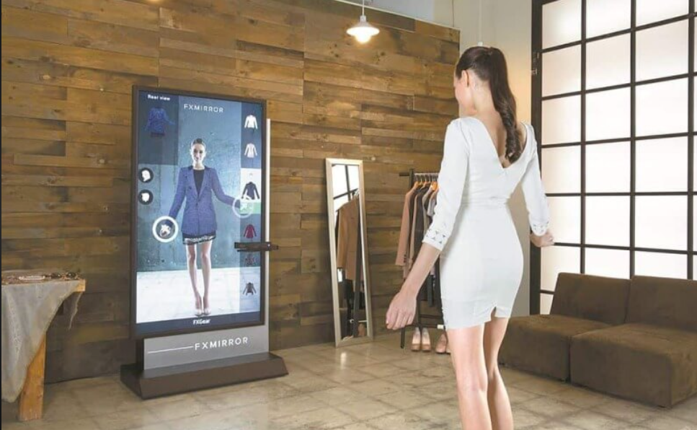**AI-Powered Virtual Try-On: A Business Plan**

**Fashion made easy**

**VIDHI ROHIRA**

**S.Y B.Tech CE 52**

**231071052**

**AI-Powered Virtual Try-On: A Business Plan**

This document outlines a comprehensive business plan for an AI-powered virtual try-on solution. It addresses key aspects, including the problem statement, proposed solution, market analysis, business model, marketing and sales strategy, operational plan, financial projections, impact metrics, risk analysis, team and key roles, and timeline and milestones. The plan aims to provide a roadmap for the successful development, launch, and growth of the AI-powered virtual try-on platform.



# Problem Statement

The traditional clothing shopping experience often lacks convenience and personalization. Customers struggle to find the right fit, style, and size, leading to frustration and returns. This creates inefficiencies for both consumers and retailers. E-commerce platforms, while offering convenience, fall short in providing realistic virtual try-on experiences. Existing virtual try-on solutions are often clunky, inaccurate, or limited to specific types of clothing. There's a gap in the market for a robust, user-friendly, and AI-powered virtual try-on solution that seamlessly integrates with online shopping experiences and provides accurate, personalized results.

# Solution / Product Offering

Our AI-powered virtual try-on solution utilizes advanced computer vision and machine learning algorithms to create realistic and personalized virtual try-on experiences for customers. Our platform integrates seamlessly with e-commerce websites and mobile apps, allowing users to try on clothing virtually without the need for physical fitting rooms. This solution offers:

* **Accurate Size and Fit Predictions**: Leveraging body measurements and clothing data, our AI algorithm accurately predicts how clothes will fit on individual users.
* **Realistic Visualizations**: Our system renders realistic virtual try-ons that reflect the drape, texture, and movement of garments.
* **Personalization and Style Recommendations:** Based on user preferences and body measurements, our AI provides tailored recommendations for clothing styles and sizes, enhancing the shopping experience.
* **Seamless Integration**: Our platform seamlessly integrates with existing e-commerce platforms, making it easy for retailers to implement and for customers to use.

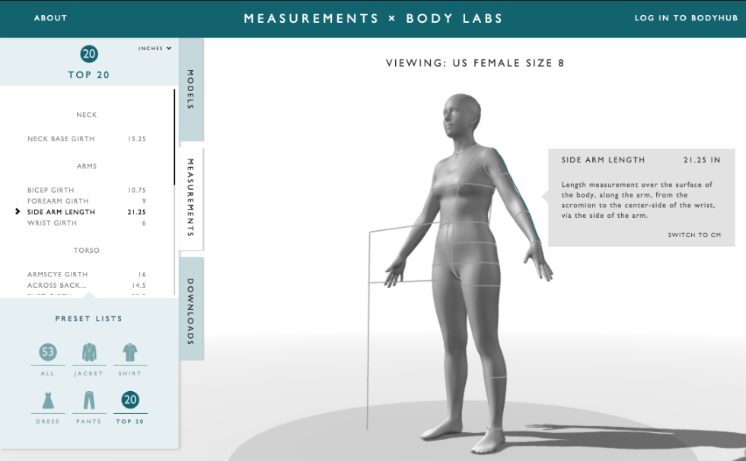

**Market Analysis**

The global virtual try-on market is experiencing rapid growth, fueled by the rising popularity of online shopping and the increasing demand for personalized experiences. The market is segmented based on technology, application, end-user, and region. Key drivers include:

* Growing e-commerce penetration
* Increasing adoption of smartphones and mobile devices
* Rising consumer demand for personalized shopping experiences
* Advances in AI and computer vision technologies

The market is also facing challenges, including:

* Technical limitations of existing solutions
* Concerns about data privacy and security
* Limited availability of high-quality data for training AI models

Despite these challenges, the virtual try-on market presents a significant opportunity for growth and innovation. Our AI-powered solution is poised to capitalize on this opportunity by addressing the shortcomings of existing solutions and offering a compelling value proposition to both retailers and consumers.

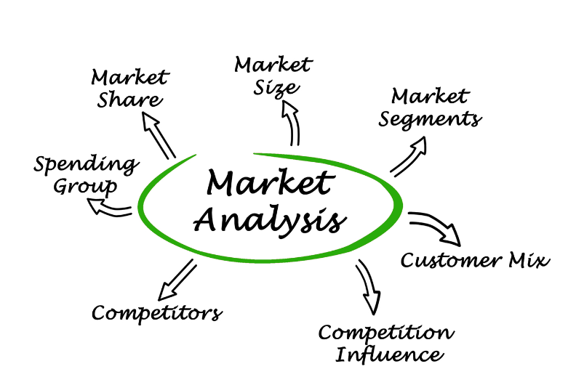

# Business Model

Our business model is based on a SaaS (Software as a Service) subscription model, offering retailers a cloud-based platform that integrates with their existing e-commerce infrastructure. Our revenue streams include:

* **Subscription Fees:** We charge monthly or annual subscription fees based on the number of users and features accessed.
* **API Integrations:** We offer APIs for developers to integrate our virtual try-on capabilities into their own platforms, generating revenue through licensing fees.
* **Data Analytics and Insights**: We provide retailers with valuable data and insights on customer behavior, preferences, and try-on data, offering a premium subscription tier with advanced analytics features.

Our pricing strategy will be competitive and flexible, tailored to different retailer needs and budgets. We will focus on building long-term partnerships with retailers by providing exceptional customer support and ongoing platform updates. We aim to be the leading provider of AI-powered virtual try-on solutions, enabling retailers to enhance their online shopping experiences and increase customer satisfaction.

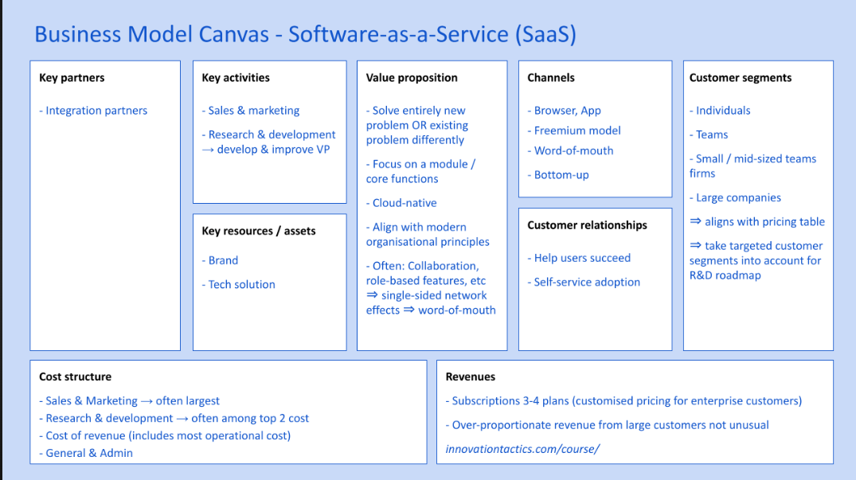

# Marketing and Sales Strategy

Our marketing and sales strategy will focus on reaching both retailers and consumers, with a targeted approach for each group. We will leverage a multi-channel marketing strategy, including:

* **Digital Marketing**: Utilizing search engine optimization (SEO), social media marketing, content marketing, and pay-per-click advertising to reach our target audience.
* **Industry Events and Trade Shows:** Participating in relevant industry events and trade shows to showcase our solution to retailers and build relationships.
* **Partnerships and Collaborations**: Partnering with e-commerce platforms, fashion retailers, and industry influencers to expand our reach and credibility.
* **Public Relations and Media Outreach**: Sharing news and insights about our solution through press releases, media coverage, and influencer marketing.

Our sales team will focus on building strong relationships with retailers, understanding their specific needs, and demonstrating how our solution can help them achieve their business goals. We will offer personalized demos, case studies, and tailored proposals to highlight the value proposition of our virtual try-on solution.

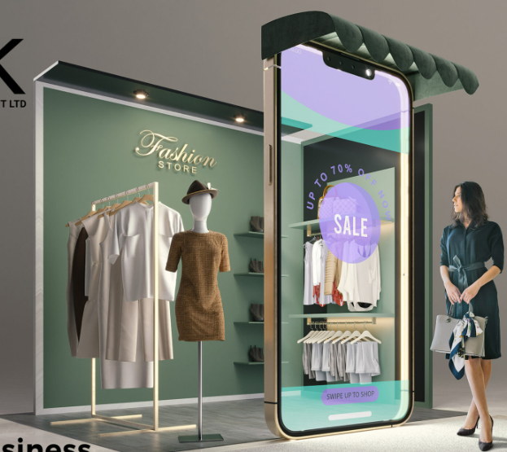

# Operational Plan

Our operational plan outlines the key processes and resources required to develop, launch, and operate our AI-powered virtual try-on solution. The plan includes:

* **Product Development**: A dedicated team of engineers and data scientists will develop and maintain our AI platform, ensuring its accuracy, performance, and scalability.
* **Customer Support:** A dedicated support team will be responsible for resolving customer queries, onboarding new retailers, and providing ongoing technical assistance.
* **Data Management:** A robust data management system will be implemented to ensure the security, privacy, and integrity of user data, adhering to industry best practices and regulations.
* **Infrastructure and Scalability:** Our platform will be hosted on a cloud-based infrastructure, enabling scalability and high availability to accommodate growing user demand.

# Financial Projections

Our financial projections demonstrate the projected revenue, expenses, and profitability of our AI-powered virtual try-on solution over the next three years. The projections are based on our market research, competitive analysis, and industry trends. We will use a variety of financial models to assess the impact of different growth scenarios, pricing strategies, and market conditions. The projections will include:

* **Revenue Projections:** Based on the projected number of subscribers and revenue streams, we will project annual revenue growth.
* **Expense Projections:** We will project operating expenses related to product development, marketing, customer support, and infrastructure.
* **Profitability Analysis**: We will assess the profitability of the business model, considering revenue, expenses, and potential profit margins.
* **Funding Requirements**: We will estimate the funding requirements for the initial development, launch, and growth of the platform, identifying potential sources of funding.

# Risk Analysis

We have identified several key risks associated with our AI-powered virtual try-on solution. These risks include:

* **Technological Challenges:** The rapid pace of technological advancements could require ongoing adaptation and development to ensure our solution remains competitive.
* **Data Privacy and Security**: Ensuring the security and privacy of user data is paramount. We will implement strong security measures and comply with relevant data protection regulations.
* **Competition:** The virtual try-on market is becoming increasingly competitive. We will differentiate our solution by focusing on accuracy, personalization, and seamless integration.
* **Market Adoption:** Gaining widespread adoption from retailers is crucial for our success. We will focus on building strong partnerships and demonstrating the value proposition of our solution.

We have developed mitigation strategies to address these risks. We will invest in research and development to stay ahead of technological trends, prioritize data security, and actively seek partnerships to expand our market reach. By proactively addressing these risks, we aim to ensure the long-term viability and success of our AI-powered virtual try-on solution.

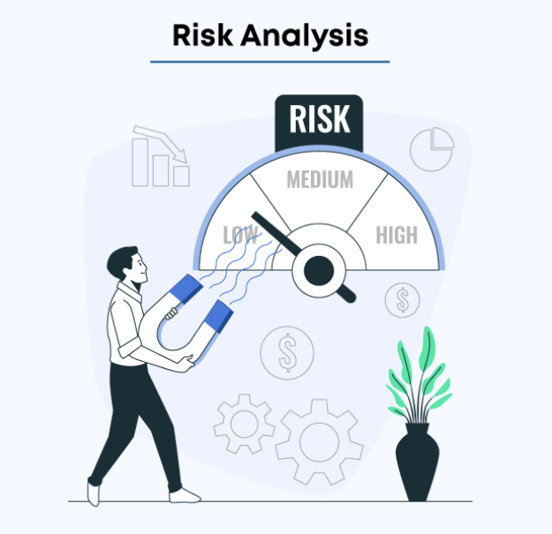

**Team and Key Roles**

**Skills and Experience**

* **AR/AI Development**: Developers with expertise in augmented reality and machine learning.
* **Fashion Industry Knowledge**: Experts who understand the needs of fashion retailers and online shoppers.
* **Marketing**: Professionals experienced in digital marketing, especially within the fashion and e-commerce industries.

**Key Team Members or Advisors**

* **Founder/CEO**: Background in fashion and technology.
* **CTO**: Expertise in AR/AI technologies.

**Plan for Team Growth**

* Hire additional developers and customer support staff as the platform scales.
* Expand the marketing team to handle increased demand.

### **Timeline and Milestones**

**Short-Term (1 Year)**

* Complete initial platform development.
* Secure partnerships with 2-3 retailers for integration.

**Long-Term (3-5 Years)**

* Expand into international markets.
* Grow to 1 million active users.
* Secure Series A funding to support expansion and tech enhancements.

**Key Targets**

* **Year 1**: Secure partnerships, onboard initial users.
* **Year 3**: Reach break-even point, expand internationally.
* **Year 5**: Hit $20 million in revenue and become a market leader in AR-based virtual try-ons.